Using WinRAR to compress or save a file as .ZIP
- Right-click the file.
- Select “Add to Archive…”.
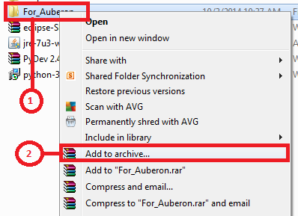
- Select “ZIP” and click OK button.
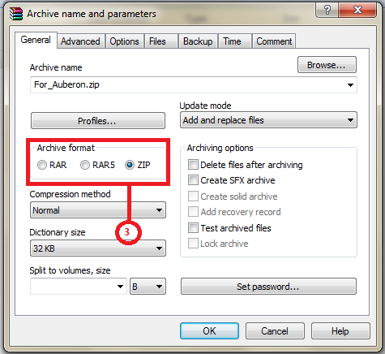
- Choose the file with File Type “WinRAR ZIP archive” to send to recipient.
